You are the lead process developer for Kirby’s Salad Dressings a better for you salad dressing company. The business team has decided that the next move for the company is to launch a new ranch flavored, salad dressing. This product will need to create and hold the creamy emulsion that consumers expect with their salad dressings. Sales has anticipated that this will be a big seller for you and is anticipating a sales volume of 2.4 milllion cases/ year. Sales has also indicated that the product should be sold in 16 floz bottles and that each case should have 8 bottles in it. Operations lets you know that the factory this will go in runs 7 days a week, 24 hrs/day, 50 weeks/yr. They anticipate an efficiency of 80%. The lead product developer and you have been assigned to the project. After the product developer creates the initial prototype, you begin work on a process flow diagram using the formula shown below.

|  |  |
| --- | --- |
| Kirby's Ranch Dressing | |
| Ingredients | % Formula by weight |
| Soybean Oil | 50% |
| Water | 25% |
| Buttermilk | 15% |
| Sugar | 3.80% |
| Salt | 2.50% |
| Vinegar | 1% |
| Egg Yolk | 1.50% |
| Spice Blend | 1% |
| Xanthan gum | 0.20% |
|  | 100% |

Using the prototype given you go over to analytical testing to get a density which they report as ---lb/floz.

The product developer has described their process to you. First, some of the water, spice blend, eggs, salt, sugar, vinegar, and xanthan gum are mixed together. Then the rest of the water, buttermilk, and soybean oil are combined in a high shear device to create an emulsion. This mixture then flows to a filler which fills the bottles. Knowing the basic needs for the line, you go about creating a block flow diagram. For the initial mix tank, you select a Breddo tank which can provide very good mixing in a batch tank. For the high shear device you choose a Dispax, which can provide high local shear and reduce fat droplet size creating the emulsion consumers expect. For the filler you choose a volumetric rotary filler to be able to keep up with the production rate. The process flow diagram is shown below. Pictures of the devices can be seen in the appendix.

1. For each of the numbered streams, give a flow rate in lbs/hr in order to meet production demands.
2. Which of the following Dispax machines should be chosen knowing that any additional capacity comes at an increased cost? A picture containing graphical user interface

   Description automatically generated
3. During pilot plant testing, it has been foud that the xanthan gum is not sufficiently mixed during the breddo step and is clumping. To combat this, an oil/xanthan gum slurry needs to be prepared using oil 5 times the weight of the xanthan gum. Recalculate the flow rates replacing stream 6 with the xanthan/oil slurry.
4. Assuming the water egg blend coming out of the breddo is about the density of water, what size of breddo tank would be needed?

Appendix

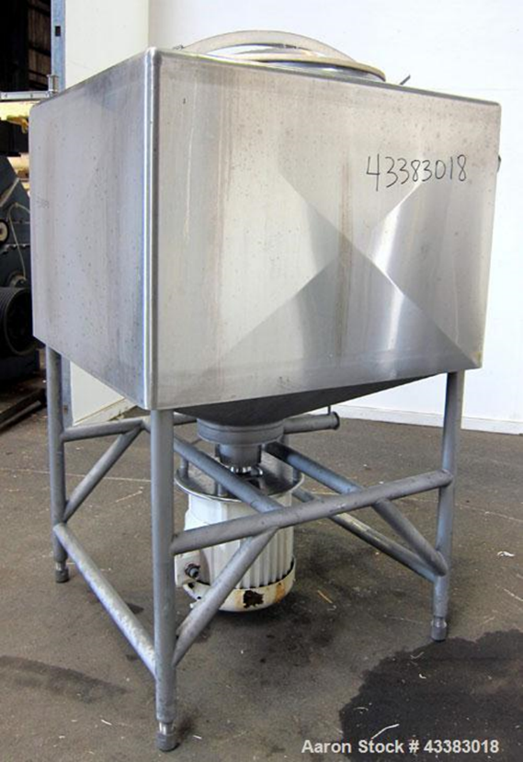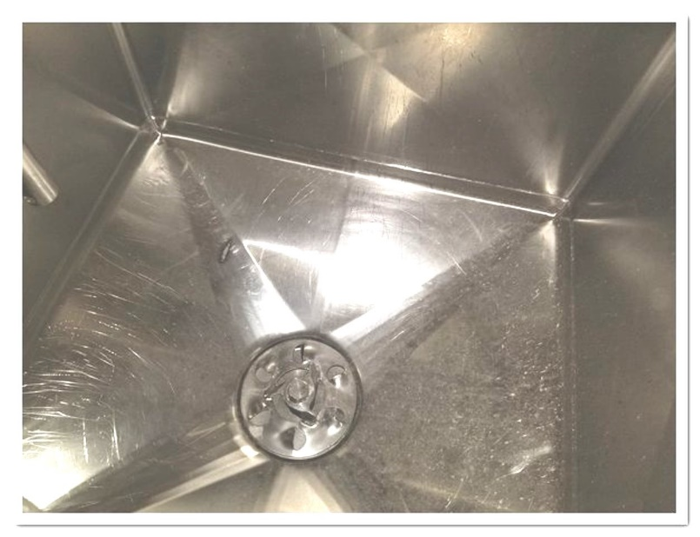

Breddo Tank (outside and inside)

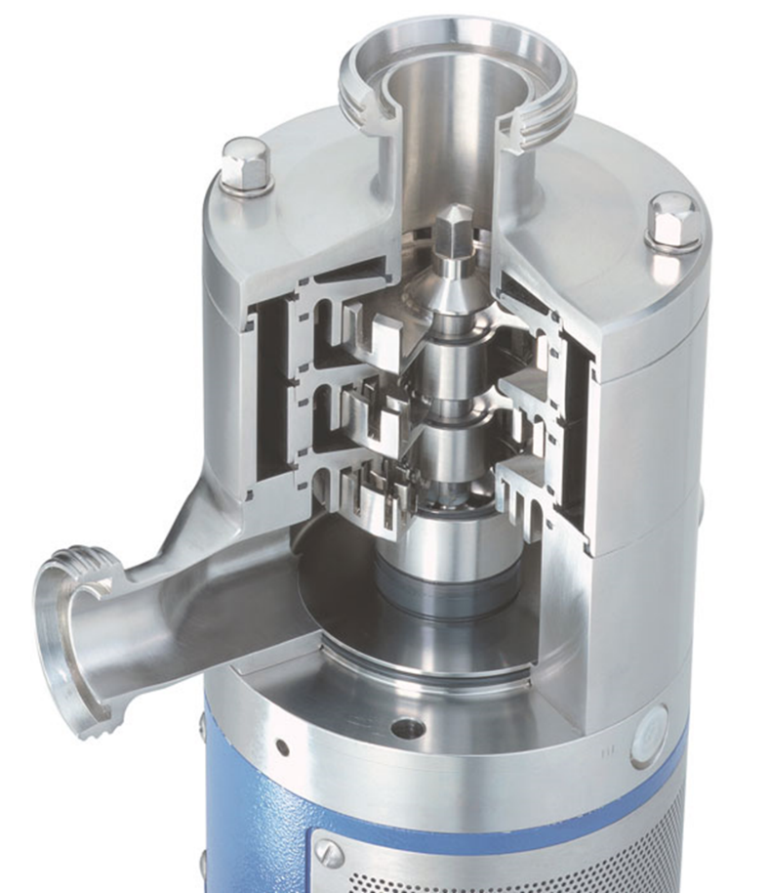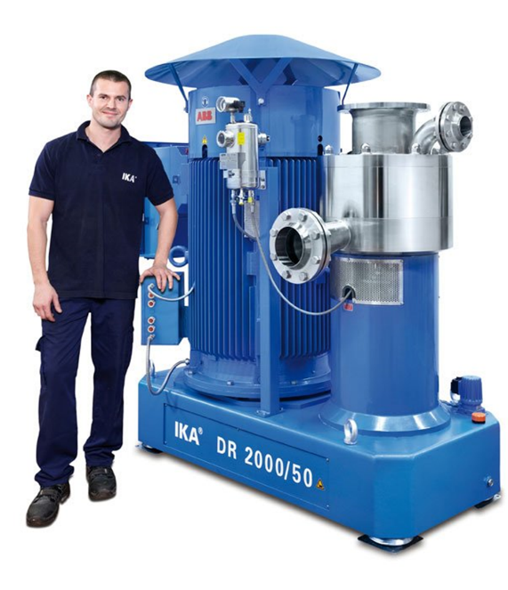

Dispax Mill (Cutaway and with a person for scale)

Videos for rotary fillers

[Rotary Liquid/Water Filling Machines - Filling Equipment Company, Inc.](https://www.fillingequipment.com/product/rotary-water-filling-machine/)